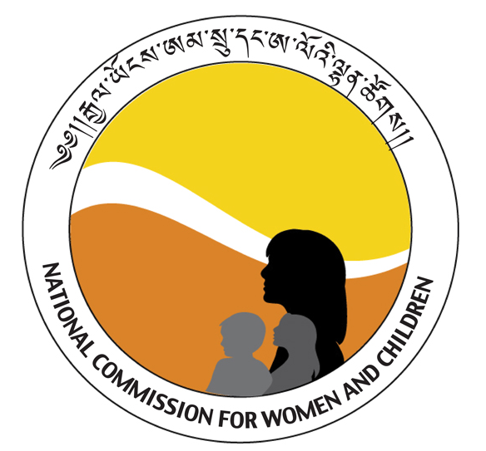
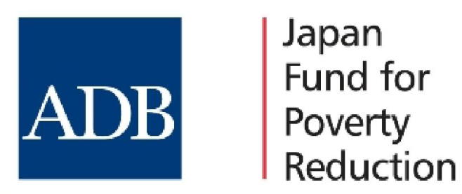

OUTLINE TERMS OF REFERENCE FOR CONSULTING SERVICES: Development of Gender Advocacy Materials

- Background
The National Commission for Women and Children (NCWC) is implementing the project “Advancing Economic Opportunities of Women and Girls” funded by the Japan Fund for Poverty Reduction (JFPR) through the Asian Development Bank (ADB). The Project aims at improving the economic status of vulnerable women and girls in selected urban and rural areas by enhancing their capacity to access livelihood (including microenterprise) and employment opportunities.
Component A of the project focuses on strengthening the capacity of the NCWC in program design, monitoring, advocacy and networking, and gender mainstreaming. This component will involve: (i) implementing a plan to strengthen the capacity of the NCWC, and to advocate for and improve the gender mainstreaming capacities of the gender focal points; (ii) developing a system to monitor gender mainstreaming in government agencies and in the implementation of the NPAG, 2008–2013; (iii) developing gender mainstreaming tools, gender advocacy campaign materials, and sector-specific gender strategies for selected line agencies involved in the economic empowerment of women and relevant to Asian Development Bank (ADB) operations in Bhutan.
One of the core activities under the component is implementation of a program targeted at advocating for gender sensitive policies and development of gender advocacy materials. Advocacy materials will be developed on the rights of women and men representing most vulnerable groups of people.

II. Objective and scope of the work of the Consultancy Service

The main objectives of the consultancy service is to plan, coordinate and develop gender responsive advocacy materials for identified sector agencies

III. Duties and Responsibilities

Under the overall supervision of the National Gender and Social Development Officer and the Women’s Division of NCWC, the Consultant will be responsible for ensuring synergy in advocacy, advice and capacity development of the J9155 Project beneficiaries through implementation of the following responsibilities:
- Assist the PMU, J9155 (BHU) , NCWC in the organization of advocacy materials for the rights of women and men representing most vulnerable groups of people in promoting gender equality at the national and community levels, including:
  - Draft texts and design of gender awareness-raising and advocacy materials: leaflets, posters, brochure for NCWC and key sectors identified by the NCWC
  - Develop print advocacy materials based on content concepts/idea of sector agencies
  - Support the organization of specific awareness–raising and advocacy activities as per the action plan.

IV.Deliverables
- Electronic copy of posters on the following themes:
- The need of Gender Equality in Agriculture;
- The need of Gender Equality in Employment; and
- The need of Gender Equality in Training and Education
- Pictorial representation of chapters of the Domestic Violence Act

- Flyers on:
- Key Gender Statistics; and
- Key Gender Terms, Concepts and Examples
- Gender Mainstreaming Tools

- Stickers on Domestic Violence
V. Broad Qualification criteria for experts

- Masters in Information Technology with Specialization in Graphic Designing
- Minimum of 5 years of relevant experience.
- Experience of having worked with multiple stakeholders, including government, private, and civil society.
- Evidence of strong organizational skills and ability to work independently.
- Excellent analytical and writing skills
- Applicants with experience in development of similar materials will be given preference.

